Handout no. 1

|  |  |
| --- | --- |
| **Name** |  |
| **Reg. No** |  |
| **Marks/Grade** |  |

**EXPERIMENT # 1**

**Introduction to Power World Simulator. Symmetrical and Unsymmetrical Fault analysis in Power world Simulator**.

**Objective:**

At the end of this lab session students will be able to

* To design Electric Power Transmission system in in Power World Simulator.
* To observe power flow in power System.
* To analyse different types of faults.

**Introduction:**

Power World is a great and “powerful” utility for solving power flows. Solving a power system is a little different from circuit analysis. Instead of being given voltages at certain nodes or impedances, you are often given load and generator powers. This makes solving the circuit difficult to do by hand, but easy using a tool like Power World. Most utilities use Power World or similar programs for solving their systems, such as PSS/E.

Adding Power World to your CAE Start Menu:

1. Add Power World to your CAE start menu. In a CAE computer lab, click Start -> CAE Applications ->Add Applications to Start Menu, and search for Power World.

2. Launch Power World**.**

**Mode of Operations:**

There is two modes of operations.

* Run Mode
* Edit Mode

**Edit Mode of Operation:**

In edit mode of operation the network is designed. All changings of network is done in this mode of operation. The window of draw network is in Edit mode of operation in which options of drawing all components are presents.

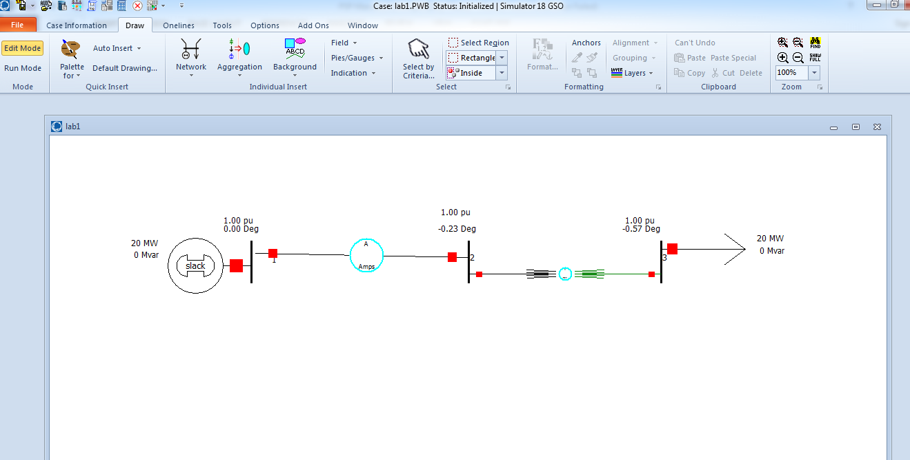

Figure No: 1

**Run Mode:**

In run mode system power flow is analysed. Active and reactive power at each bus is analysed. All fault analysis can be done in run mode of operation.

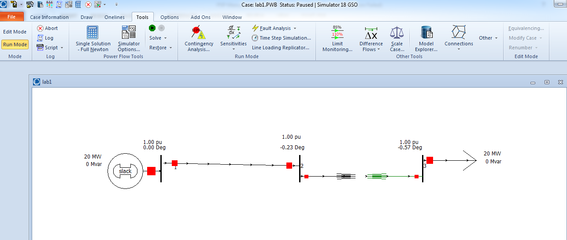

Figure No: 2

**Fault Analysis:**

Electrical fault is the deviation of voltages and currents from nominal values or states. Under normal operating conditions, power system equipment or lines carry normal voltages and currents which results in a safer operation of the system.

But when fault occurs, it causes excessively high currents to flow which causes the damage to equipment’s and devices. Fault detection and analysis is necessary to select or design suitable switchgear equipment, electromechanical relays, circuit breakers and other protection devices.

**Symmetrical faults**

These are very severe faults and occur infrequently in the power systems. These are also called as balanced faults and are of two types namely line to line to line to ground (L-L-L-G) and line to line to line (L-L-L).

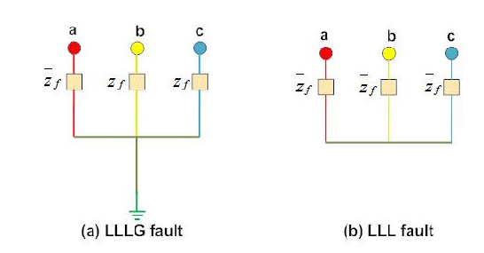

**Unsymmetrical faults**

These are very common and less severe than symmetrical faults. There are mainly three types namely line to ground (L-G), line to line (L-L) and double line to ground (LL-G) faults.

**Lab Task:**

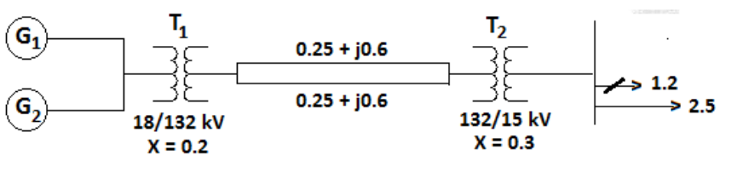

Generator 1 MW output: 30, -5 MVar

Generator 2 MW output: 35, -5 Mvar

Load 1: 25 M, Load 2: 20 MW and 5 Mvar

A power system on 100 MVA base is shown in fig. below; the generators real power, real and reactive  
loads, transformer reactance and transmission line parameters are all shown in per unit. Simulate the  
system using **Power World Simulator** and show the following quantities.

1. Sending end voltage in per unit and in kV  
   b) Receiving end voltage in per unit and in kV  
   c) Sending end power factor  
   d) Receiving end power factor

Part b:

Determine the amount of shunt compensation at the receiving end such that the receiving end voltage  
remains within 0.99 to 1.01 per unit

Part C:

1. Three phase solid fault at bus no. 1
2. Three phase fault at bus no. 2 with the fault impedance of 0.5 per unit
3. Three phase fault on the line 1-2 at the location of 20% from the generation bus
4. Three phase fault on the line 1-2 at the mid-point
5. Mismatches of the buses

Admittance matrix of the system

Same analysis should be done for Single Line to Ground Fault and Line to Line Fault.

Note:

Values of Impedance must be put in per unit system.

**Home Assignment:**

Fig. below shows the one-line diagram of a simple three-bus power system with generation at bus 1.

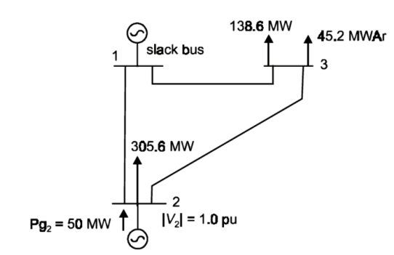

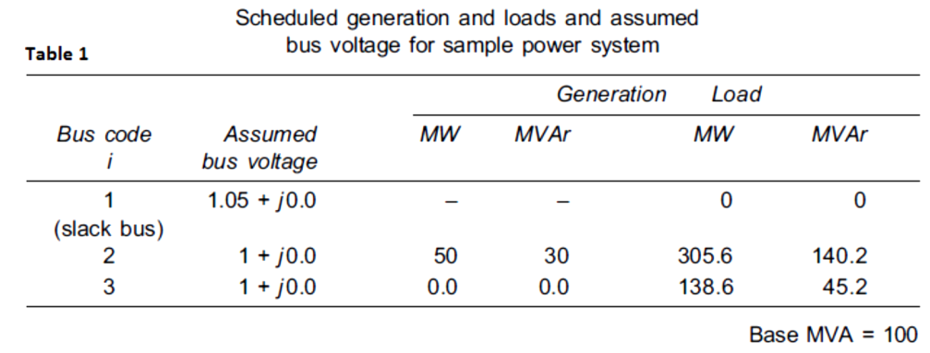

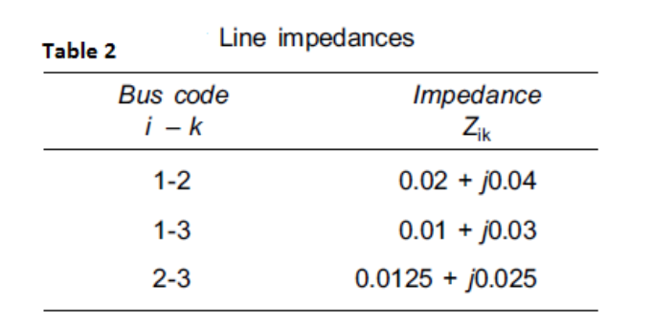

Using the **Power World Simulator**, calculate the fault currents and bus fault voltages using **fault analysis for** the following cases

1. Three phase solid fault at bus no. 3
2. Three phase fault at bus no. 2 with the fault impedance of 0.5 per unit
3. Three phase fault on the line 1-2 at the location of 20% from the generation bus
4. Three phase fault on the line 2-3 at the mid-point
5. Mismatches of the buses
6. Admittance matrix of the system

Same analysis should be done for Single Line to Ground Fault and Line to Line Fault.

.